Run Summary

 | Test name: | Flight Reservation
 | Test instance: | Flight Reservation
 | Status: |  | Failed
 | Run name: | Run_10-8_11-28-21
 |  | sa
 | Start time: | 08/10/2014 11:57:14
 | End time: | 08/10/2014 12:16:31
 | Duration: | 00:19:17

Steps | User  Actions | Submitted  Defects | Comments
7 | 19 | 0 | 0

# | Step | User Actions
2 |  Sign-On to Mercury Tours Application  1. Type the <<<User Name>>> in the User Name field.  2. Type the <<<Password>>> in the Password field.  3. Click the Sign-On button.
  1. Enter "inbar_shani" in the "userName" edit field.
  2. Enter the encrypted password in the "password" edit field.
  3. Click the "Sign-In" image.
  4. Click the "Application Blocked" window.
3 | Find Flight  - Select the <<<Round or Oneway>>> trip option.  - Select <<<Number Of Passengers>>> from the Passengers list.  - Select Departing From and Arriving In locations (selected items must be different).  - Select departing flight and returning flight dates. (Both dates must be set as future dates. The departing flight date must precede the returning flight date.)  - Select the <<<Class of Service>>> class option.  - Select <<<Airline>>> from the Airline list.  - Click the Continue button.
  5. Select the "Frankfurt" item from the "fromPort" combo box.
  6. combo box '"fromDay"' - method 'Set' invoked (parameters: 19).
  7. Select the "Sydney" item from the "toPort" combo box.
  8. combo box '"toDay"' - method 'Set' invoked (parameters: 25).
  9. Select the "Business" radio button in the "servClass" radio group.
  10. Click the "findFlights" image.
4 | Select Flight  - Select <<<Depart Flight>>> flight from Depart list  - If Round trip option selected, select <<<Return Flight>>> flight from Return list.  - Click the Continue button.
  11. Click the "outFlight" radio group.
  12. Click the "inFlight" radio group.
  13. Click the "reserveFlights" image.
5 | Book Flight  - Complete the First Name and Last Name fields.  - Select the <meal preference> from the Meal list.  - Select the <<<Credit Card Type>>> from the Card Type list.  - Complete the credit card Number field.  - Select the <<<Credit Card Expiration Month and Year>>> from the credit card Expiration list.  - Complete the credit card owner First, Middle and Last Name fields.  - <<<Ticketless Travel: Select/Do Not Select>>> Ticketless Travel option.  - Complete the Billing Address section.  - <<<Same as Billing Address: Select/Do Not Select>>> Same as Billing Address option.  - If Ticketless Travel and Same as Billing Address options are not selected, complete the Delivery Address section.  - Click the Secure Purchase button.
  14. Enter "Inbar" in the "passFirst0" edit field.
  15. Enter "Shani" in the "passLast0" edit field.
  16. Enter "972" in the "creditnumber" edit field.
  17. Select the "Kosher" item from the "pass.1.meal" combo box.
  18. Click the "buyFlights" image.
7 |  Print Confirmation  Print the Flight Confirmation. Check each of the following possibilities: - Click the Print It! button. - Select the Print option from the File menu of the browser.
  19. Click the "printit" image.

Sign-On to Mercury Tours Application - Action 1:
Enter "inbar_shani" in the "userName" edit field.
- Submitted Defects:
None

- Comment:
None
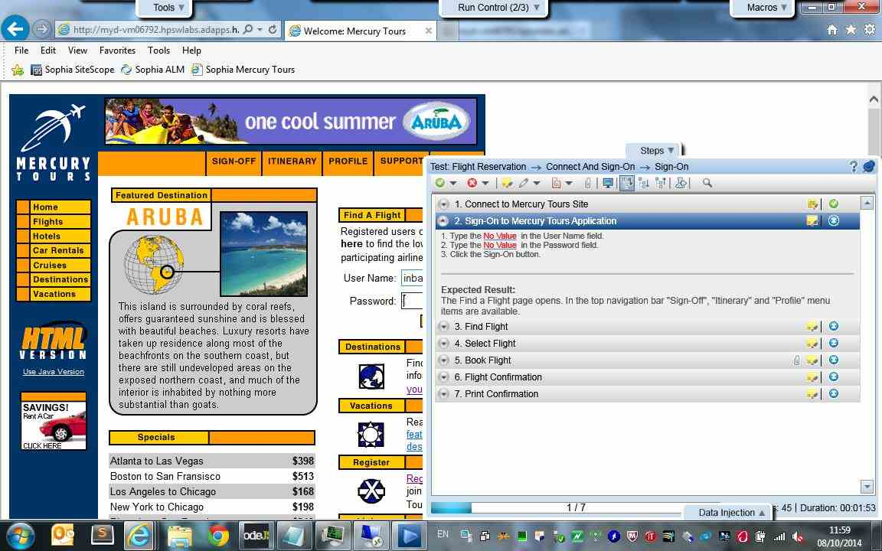

Sign-On to Mercury Tours Application - Action 2:
Enter the encrypted password in the "password" edit field.
- Submitted Defects:
None

- Comment:
None
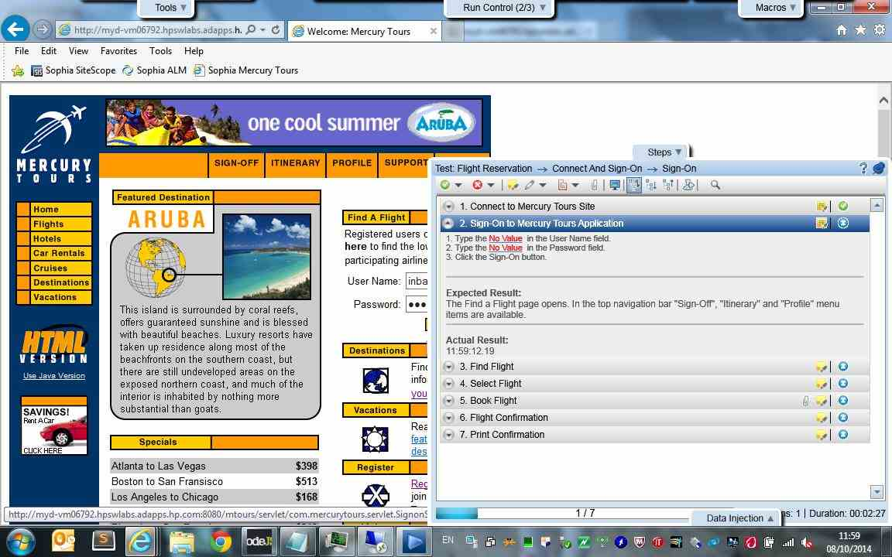

Sign-On to Mercury Tours Application - Action 3:
Click the "Sign-In" image.
- Submitted Defects:
None

- Comment:
None
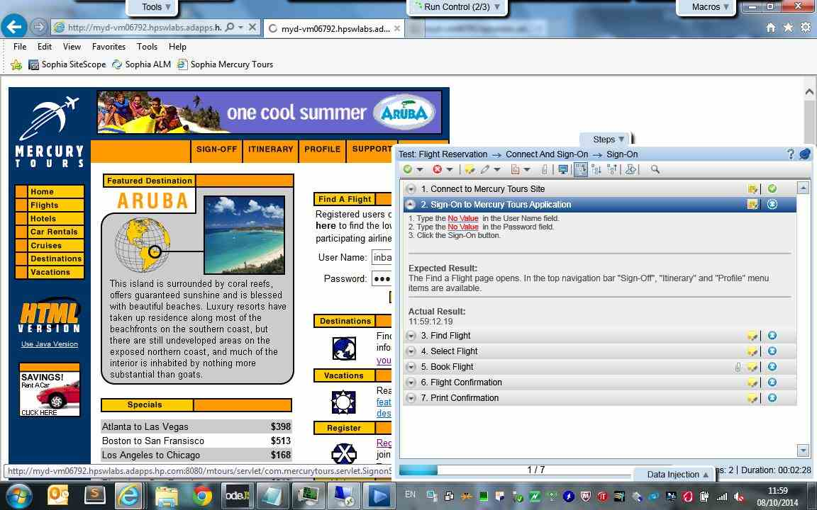

Sign-On to Mercury Tours Application - Action 4:
Click the "Application Blocked" window.
- Submitted Defects:
None

- Comment:
None
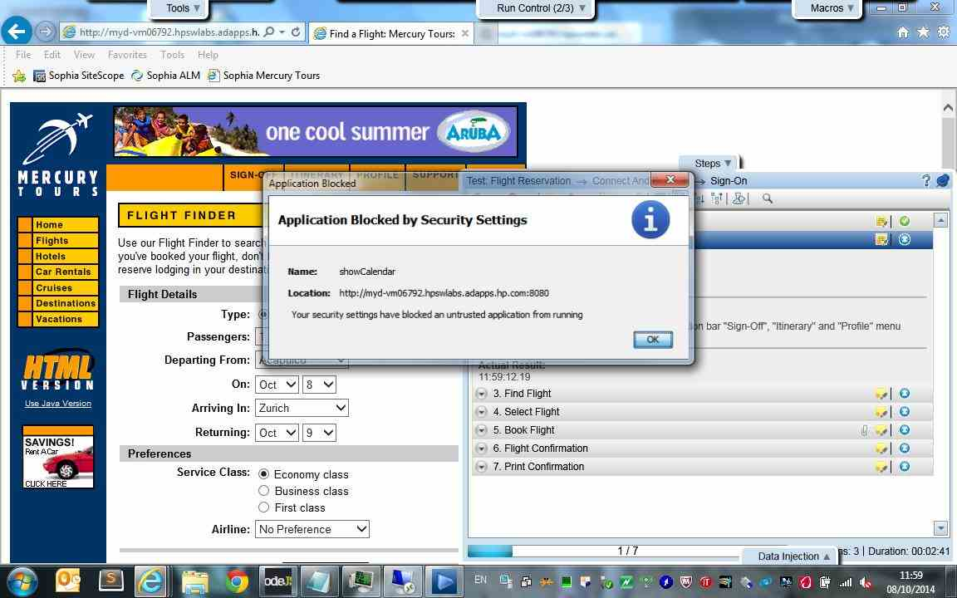

Find Flight - Action 5:
Select the "Frankfurt" item from the "fromPort" combo box.
- Submitted Defects:
None

- Comment:
None
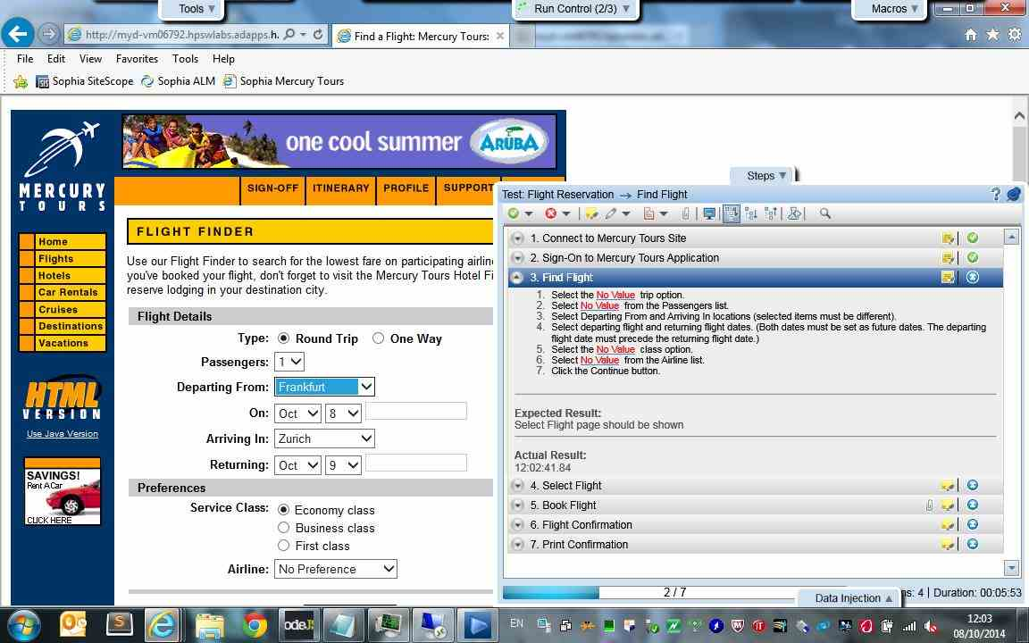

Find Flight - Action 6:
combo box '"fromDay"' - method 'Set' invoked (parameters: 19).
- Submitted Defects:
None

- Comment:
None
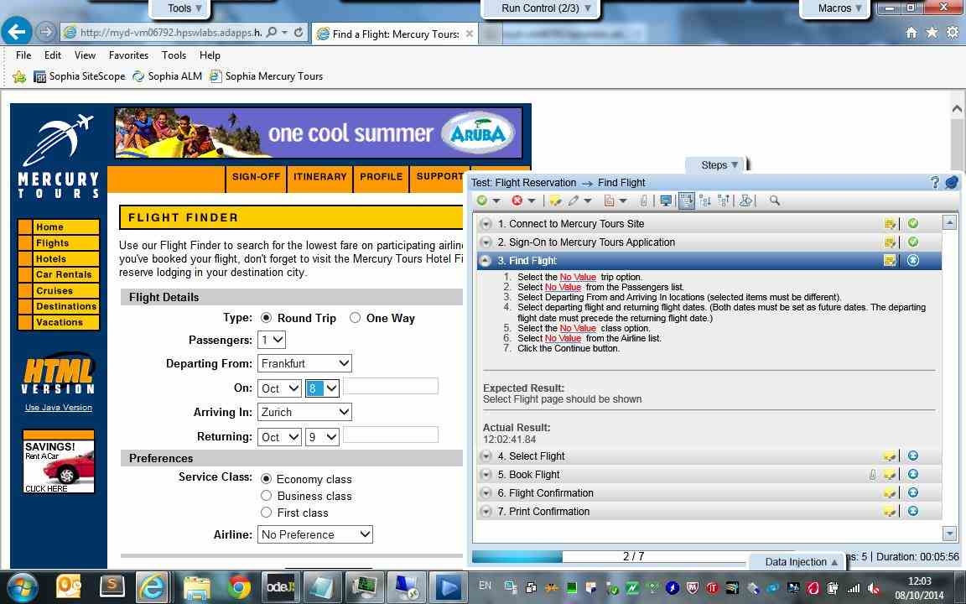

Find Flight - Action 7:
Select the "Sydney" item from the "toPort" combo box.
- Submitted Defects:
None

- Comment:
None
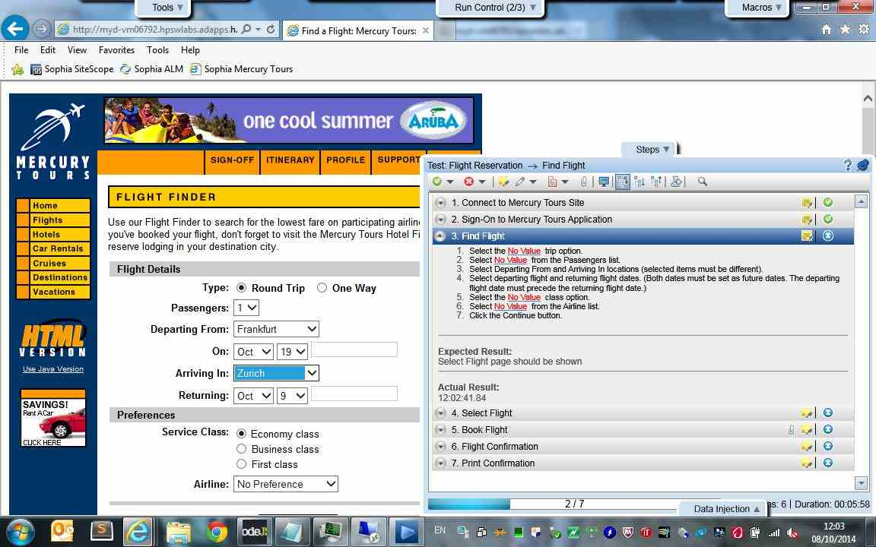

Find Flight - Action 8:
combo box '"toDay"' - method 'Set' invoked (parameters: 25).
- Submitted Defects:
None

- Comment:
None
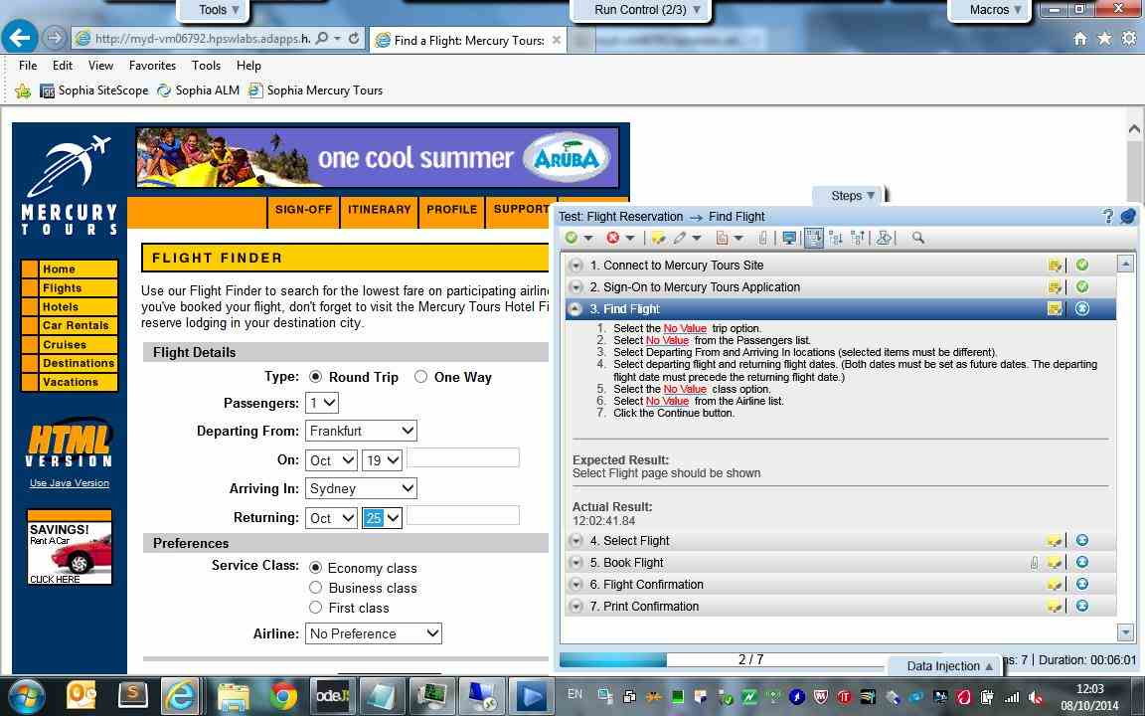

Find Flight - Action 9:
Select the "Business" radio button in the "servClass" radio group.
- Submitted Defects:
None

- Comment:
None
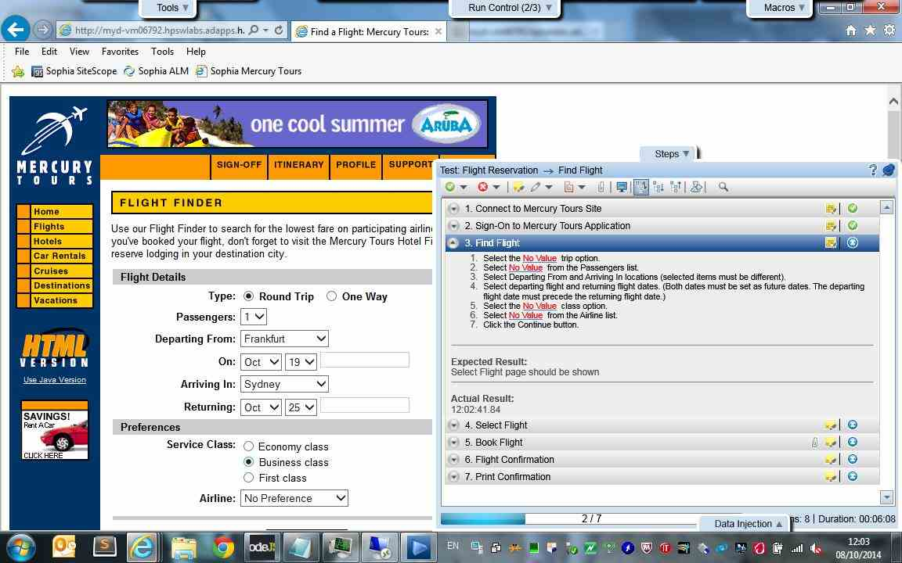

Find Flight - Action 10:
Click the "findFlights" image.
- Submitted Defects:
None

- Comment:
None
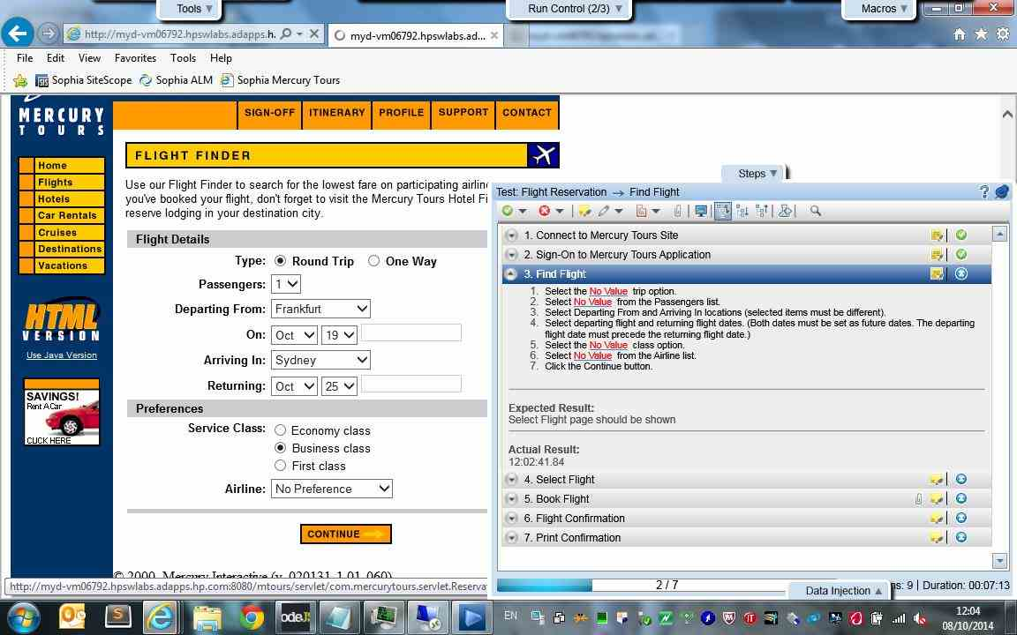

Select Flight - Action 11:
Click the "outFlight" radio group.
- Submitted Defects:
None

- Comment:
None
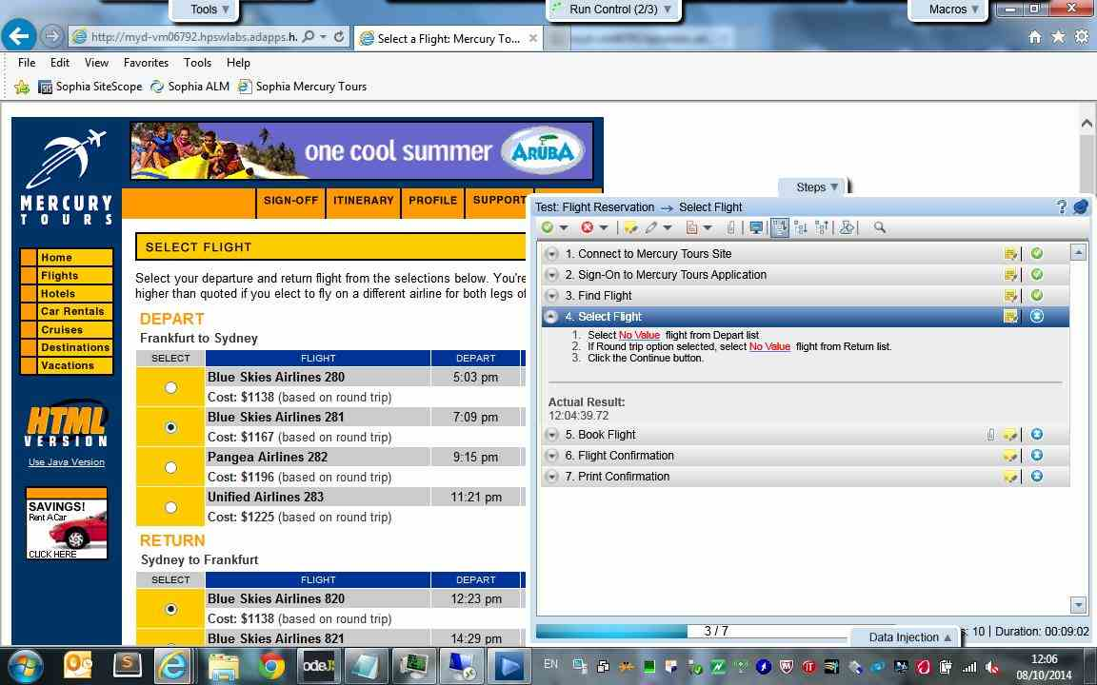

Select Flight - Action 12:
Click the "inFlight" radio group.
- Submitted Defects:
None

- Comment:
None
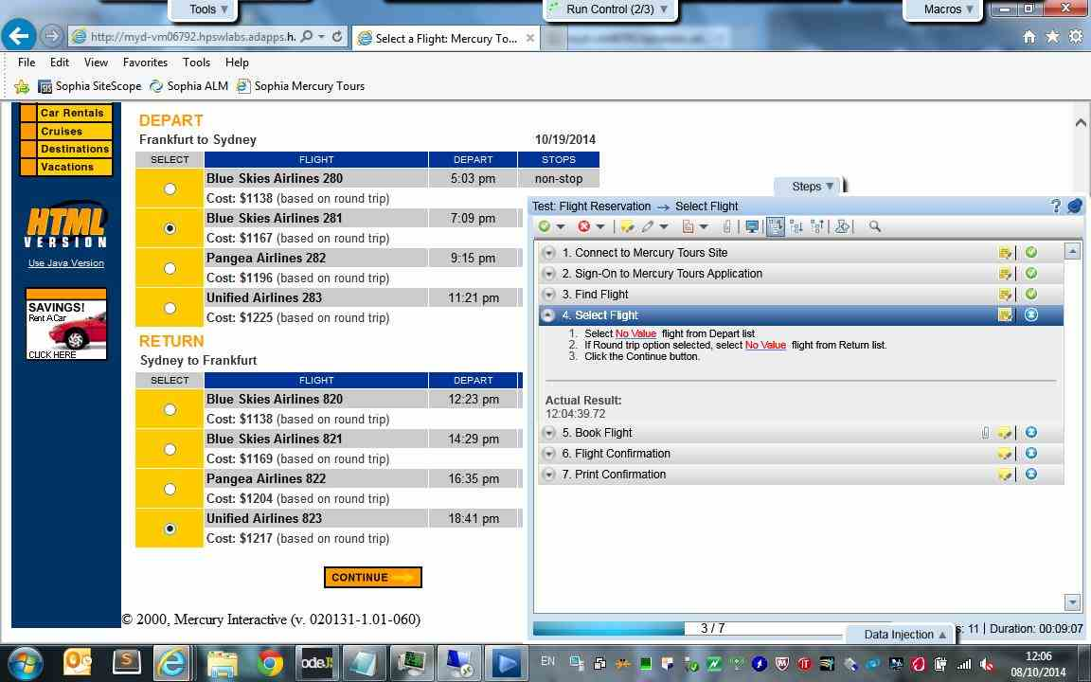

Select Flight - Action 13:
Click the "reserveFlights" image.
- Submitted Defects:
None

- Comment:
None
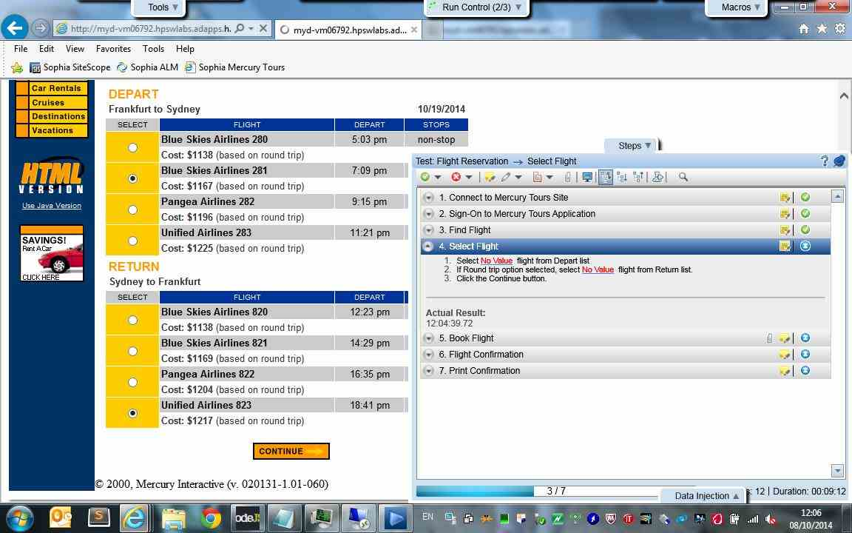

Book Flight - Action 14:
Enter "Inbar" in the "passFirst0" edit field.
- Submitted Defects:
None

- Comment:
None
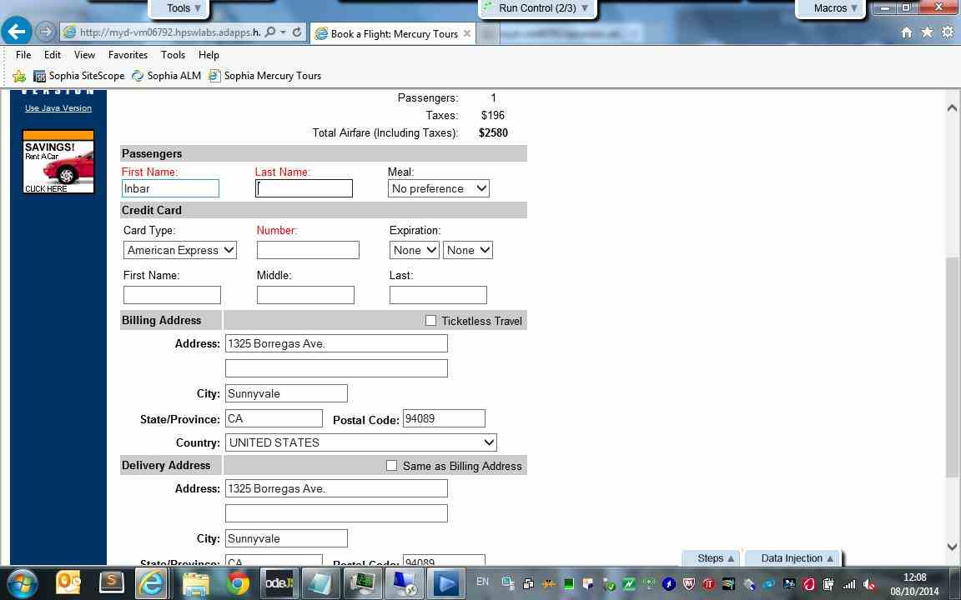

Book Flight - Action 15:
Enter "Shani" in the "passLast0" edit field.
- Submitted Defects:
None

- Comment:
None
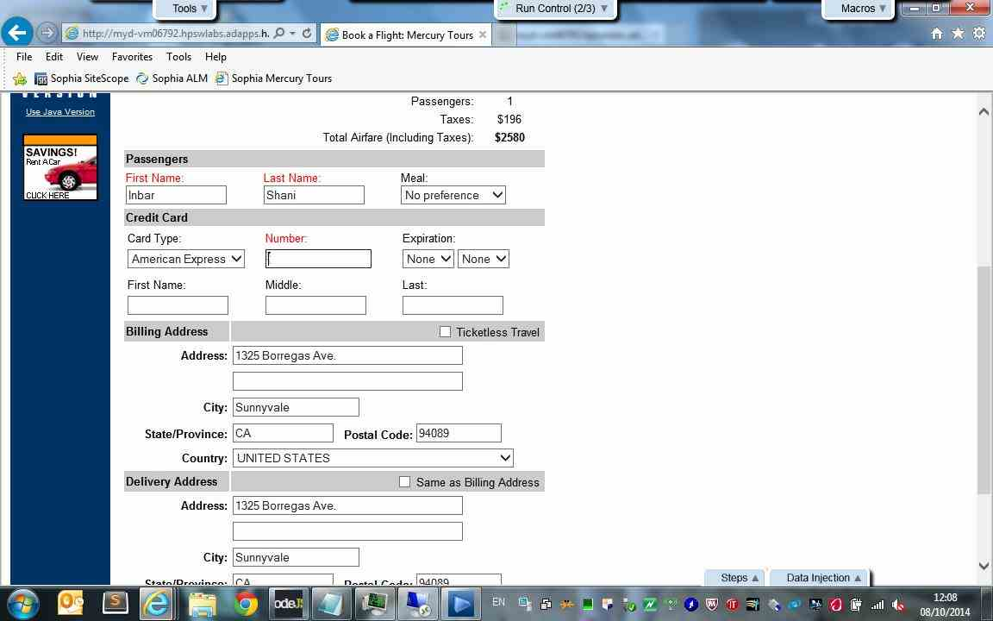

Book Flight - Action 16:
Enter "972" in the "creditnumber" edit field.
- Submitted Defects:
None

- Comment:
None
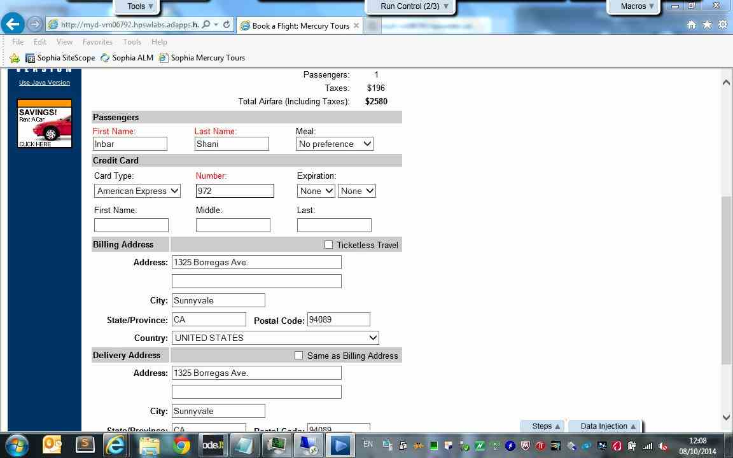

Book Flight - Action 17:
Select the "Kosher" item from the "pass.1.meal" combo box.
- Submitted Defects:
None

- Comment:
None
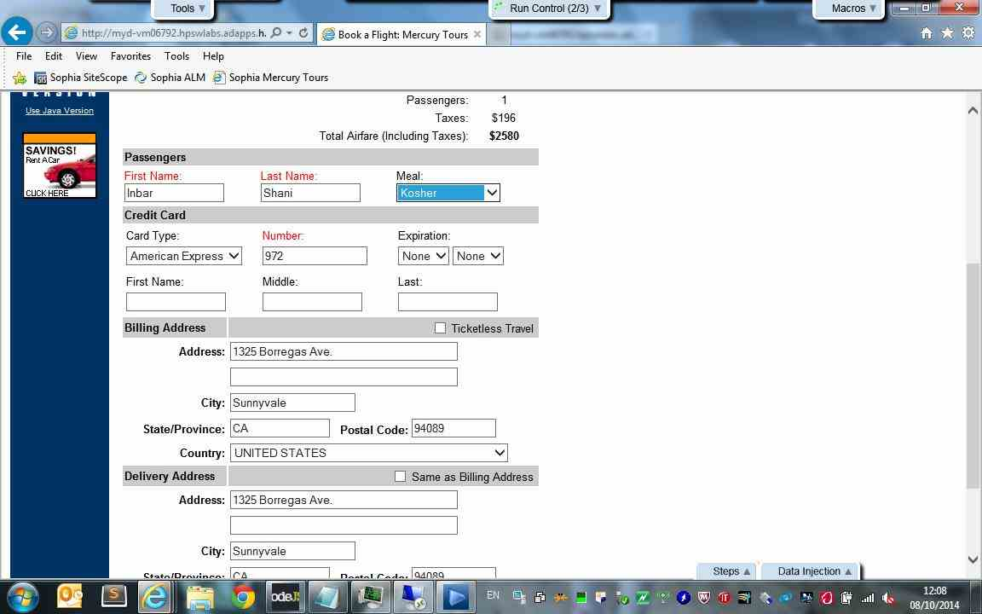

Book Flight - Action 18:
Click the "buyFlights" image.
- Submitted Defects:
None

- Comment:
None
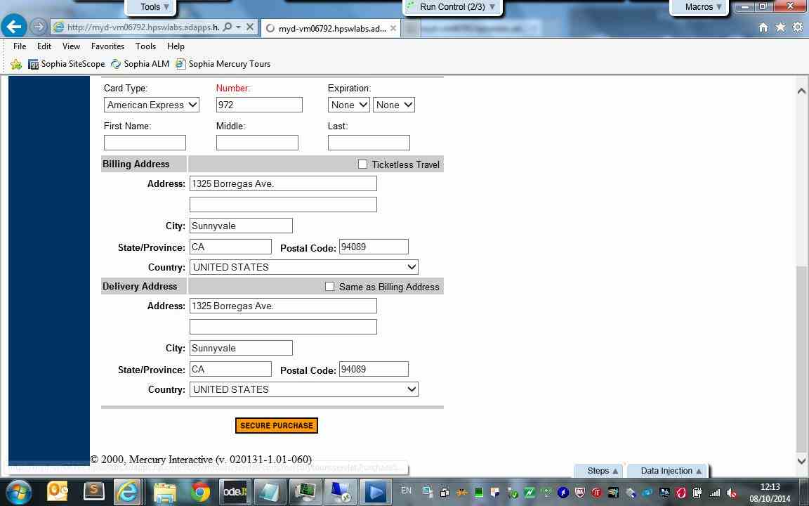

Print Confirmation - Action 19:
Click the "printit" image.
- Submitted Defects:
None

- Comment:
None
